Laudemio

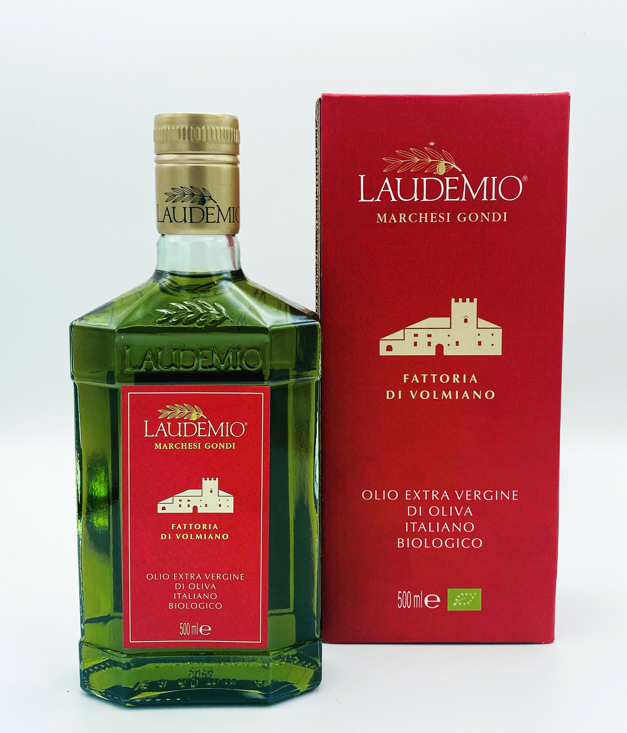
  Label:
  “Fattoria di Volmiano” Italian Organic Extra Virgin Olive Oil
  Production area:
  Entirely in the olive groves of the Fattoria di Volmiano, between 300 and 600 meters above sea level: 80 specialized hectares on which 22,000 olive trees are cultivated adopting the organic farming protocols.
  Typology:
  Organic extra virgin olive oil
  First year of bottling:
  2020
  Variety of olives:
  Frantoio 50%, Moraiolo 30% Leccino 10% other Tuscan cultivars 10%
  Olive harvest:
  Manual harvest or with facilitators directly from the plants in the months of October and November. The yard is organized so as not to damage the plants and olives.
  Oil extraction:
  The oil is extracted within 4 hours of harvesting, as the company has a line, for exclusive use, of the latest generation, capable of producing oils with a high content of polyphenols. The cold extraction process, adapted to each specific batch of olives, can work at different speeds of the crusher, with vertical malaxers that can work in slight depression. The oils are filtered, to deprive them of the aqueous residue, with plant material filters.
  View:
  Emerald green with golden reflections
  Smell and taste:
  The Laudemio di Volmiano wants to be our interpretation of the unique characteristics of the company territory. The property is spread over steeply sloping grounds, from heroic olive growing, on rocky plateaus, down to cool clayey valleys.We want the fresh and elegant aromas of rocket and almond to tell of the openings of the valleys, of the spring breezes they carry the smells of wild herbs. The artichoke bitters well represent the vigor and strength of nature, of the olive trees, which we seek, through respectful agronomic methods. The spices that close the tasting of the oil and that refresh our mouth are the children of the high concentration of vitamins in our oil. Because in Volmiano we have decided to sacrifice the quantity that our 22.00 plants would allow us to do, in favor of a unique quality, which makes our oil unique and inimitable
  Food pairings:
  The Laudemio di Volmiano 2021 is extraordinary and every gourmet combination will be enhanced. Being a very rich organoleptic palette, it is possible to use it in different phases and quantities, during preparation, to give each dish a special and unforgettable impression.
  Awards:
  3 leaves at Oli d’Italia of Gambero Rosso
  Great olive oil of Slowfood
  Gold medal at Nyiooc.

