V – IGP Toscano Colline di Firenze

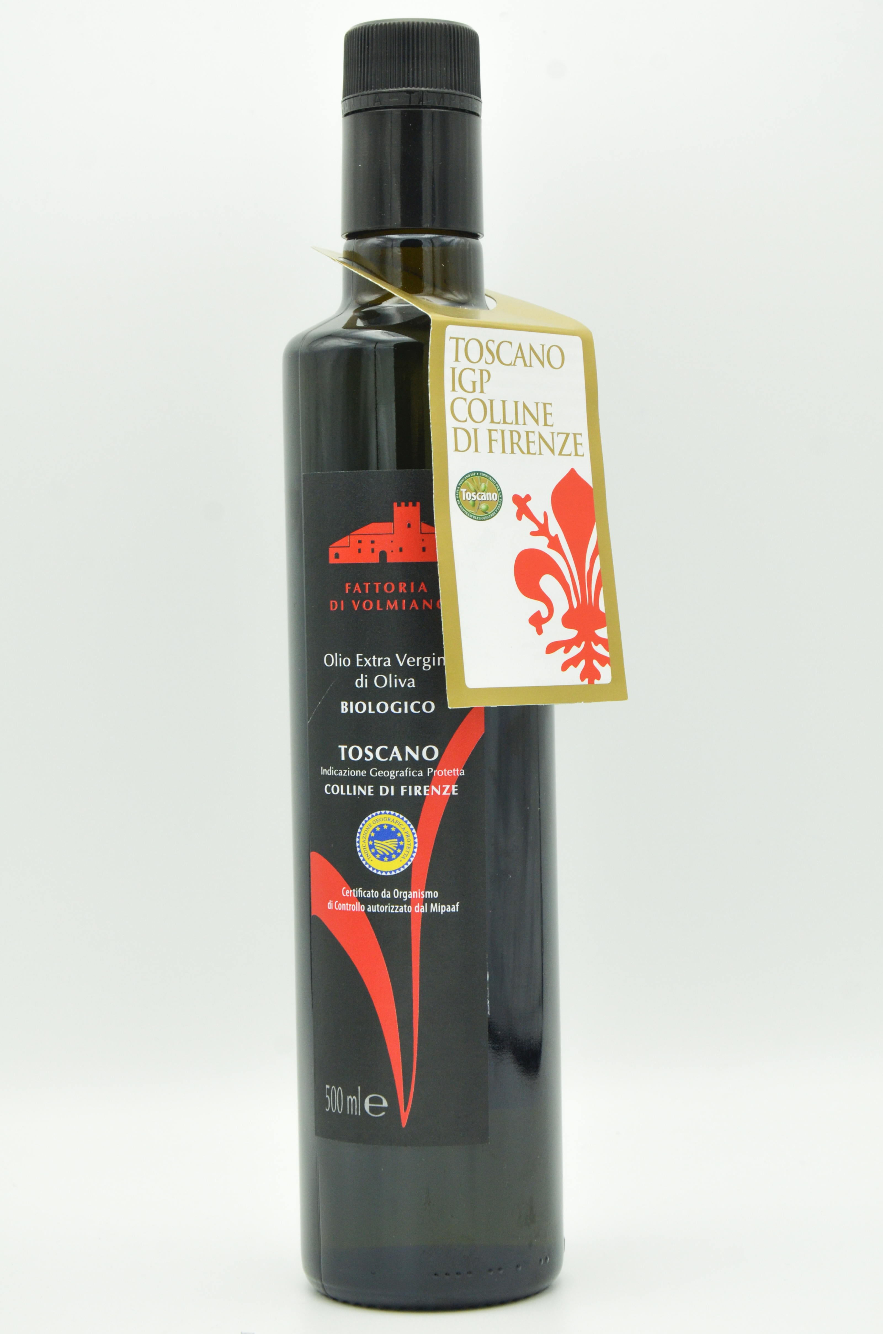
  Etichetta:
  V – IGP Toscano Colline di Firenze
  Production area:
  Entirely in the olive groves of
  the Volmiano Farm, between 300
  and 600 meters above sea level:
  80 specialized hectare on which
  22,000 olive trees are cultivated
  adopting the organic
  farming protocols.
  Typology:
  Organic extra virgin olive oil
  First year of bottling:
  2020
  Variety of olives:
  Frantoio 70%, Moraiolo 10%
  Leccino 10% other Tuscans 10%
  Olive harvest:
  Manual harvest or with
  facilitators directly from the
  plants in the months of October
  and November. The yard is
  organized so as not to damage the
  plants and olives.
  Oil extraction:
  The oil is extracted within 4
  hours of harvesting, as the
  company has a line, for exclusive
  use, of the latest generation,
  capable of producing oils with a
  high content of polyphenols. The
  cold extraction process, adapted
  to each specific batch of olives,
  can work at different speeds of
  the crusher, with vertical
  malaxers that can work in slight
  depression. The oils are
  filtered, to deprive them of the
  aqueous residue, with plant
  material filters.
  View:
  Emerald green with golden
  reflections.
  Ofact and taste:
  The Volmiano 2021 PGI aims to be
  our interpretation of the unique
  characteristics of the 2020
  vintage. The property is spread
  over steeply sloping soils, from
  heroic olive growing, on rocky
  plateaus, down to fresh clayey
  valleys. We want the elegant
  scents, of lettuce and fresh
  olive, to tell of the balance of
  Spring 2020, of the humid breezes
  that carry the smells of wild
  herbs. The bitters of thistle and
  chicory well represent the great
  temperature range between night
  and day that we saw during the
  last summer and remind us of the
  "green" that we take care of with
  respect and attention. The spicy
  notes of marjoram, which close
  with a pleasant and clean spicy
  mouth, refresh our mouth and tell
  us about autumn 2021, which saw a
  perfect alternation between hot
  days and rains, only to become
  not too cold in the past.
  collection. In Volmiano, the
  Gondi family decided to sacrifice
  the quantity that the 22,000
  plants would allow them to do, in
  favor of a unique quality, which
  makes each oil produced here
  unique and inimitable.
  Food pairings:
  Volmiano's PGI is an ingredient
  of the highest quality, so it is
  possible to combine it in every
  recipe, being able to calibrate
  its quality according to the
  contribution we would like to
  have.

